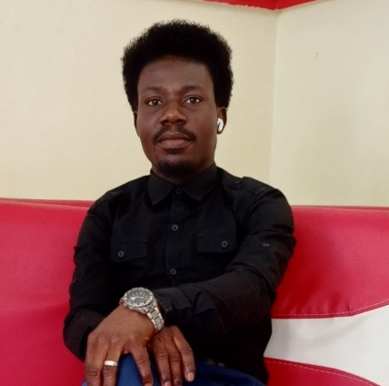**OHIA SAMUEL NWAUDO**

**No. 10 Ndachukwu Street Off Airport Road Rukpokwu Port Harcourt**

**+234-7065316332 –** [**Samuelohianwaudo@gmail.com**](mailto:Samuelohianwaudo@gmail.com)

Carrer Objectives ___________________________________________________________________

I am a dedicated and compassionate educator with commitment to fostering a supportive learning environment for students/learners. Seeking a teaching position in a very good ICT savvy environment where I can utilize my expertise in IT/ICT to inspire and empower students to reach their full potential academically, socially, and emotionally. Am passionate about implementing innovative teaching methods and fostering the love for lifelong learning in the classroom and beyond.

**Personal Data:** __________________________________________________________________________________________

Place of Birth: Omoku

State of Origin: Rivers

LGA: Ogba/Egbema/Ndoni

Marital status: Married

Date of birth: 25th March

Professional Qualifications __________________________________________________________

**PROGRAMMING HUB 2024**

Cyber Security (Basic Course)

Registration No. 1727124336565

**PROGRAMMING HUB 2024**

CSS Certification (Basic Course)

Registration No. 1727301333888

**PROGRAMMING HUB 2024**

Programming Fundamentals

Registration No. 1727304735966

**SCHOLARS INT'L INSTITUTE OF TECHNOLOGY, USA 2020**

Ethical Hacking/Diploma

Registration N0. **OS50856**

**HSE LEVEL II & III 2014**

MITA Institute

Registration No. **4021, 7537**

**INSTITUTE OF MANAGEMENT, PRODUCTIVITY AND LEADERSHIP DEVELOPMENT 2015**

Leadership/Management

Registration No. **01504772**

**TEACHERS REGISTRATION COUNCIL OF NIGERIA (TRCN) 2013**

Registration No. **DT/R/03647**

Experiences_________________________________________________________________________

**ROYAL OXBRIDGE INT’L SCHOOL, Port Harcourt (Till Date)**

ICT/Data Processing Teacher and

**LMS** Database administrator

**BRAIN ISLAND INT’L SCHOOL, Port Harcourt (2024)**

ICT/Data Processing Teacher and

**LMS** Database administrator

**OASIS CANADIAN SCHOOL, Port Harcourt (2022)**

ICT/Data Processing and Cyber security Teacher

**HALLEL COLLEGE (BOARDING), Port Harcourt (2019)**

ICT/Data Processing Teacher

**VONDORIX INT’L SCHOOL, Port Harcourt (2018)**

ICT/Data Processing Teacher

**TUA MODEL SCHOOLS (2021)**

Principal

**Duties:**

* Creates and maintains healthy, conducive, and harmonious learning and teaching environment for students, teachers, and other members of staff.
* Effectively and efficiently supervise students and staff and ensuring good and proper conduct at all times.
* Proficiently overseeing the day–to–day activities of the school.
* Supervise academic/non-academic staff and oversee day-to-day school operations.

**KINGS DOMAIN INT'L CHURCH (2016)**

Admin Officer

Handled administrative/managerial jobs

**REVIVAL ROYAL COLLEGE, Gyel Plateau State (2015)**

ICT/Data Processing Teacher and

Database administrator

**NATIONAL YOUTH SERVICE CORPS (2014)**

IT personnel

Processing electronic files and Data base Administrator

**GOD'S FAVOUR COMPUTER INSTITUTE (2008)**

Computer Instructor

Managed and instructed IT students

Soft skills

* Leadership/managerial skill
* Effective Communication skill
* Problem solving skill
* Analytical skill
* Confidentiality and secrecy
* Grith and resilience

**Technical (Hard) Skills**

* Web development (Front-end)
* Graphic design + prints
* Video editing
* Google workspace (Docs, Sheets, forms, PPT, meet)

Hobbies ___________________________________________________________________________

* Learning & Taking up new tasks
* Singing
* Playing musical instruments
* Travelling
* Reading/Research

Education __________________________________________________________________________

**IGNATIUS AJURU UNIVERSITY OF EDUCATION, PORT HARCOURT**

* M.Sc. Educational Management **(In view)**

**NATIONAL YOUTH SERVICE CORPS**

Registration No. **A002984061**

**DELTA STATE UNIVERSITY, ABRAKA**

* BSc/Ed. Computer science Second class lower

**KINGS COMPREHENSIVE COLLEGE, OMOKU**

* West African Examination Counsel (WAEC)

Registration No. **NGWASSCS 11129393**

**ST. MICHAEL'S PRIMARY SCHOOL, OMOKU**

* First School Leaving Certificate

References _________________________________________________________________________

**REV. DOMINIC L ETENG** –

CEO "Domwin global Limited "

+234 703 202 4105

**CHIEF HARRY KONDU** –

CEO "Mangroove People Leadership Initiative"

+234 803 700 8227

**PST. EMMANUEL A. OHIA** –

Pastor “Royal House of grace Int’l Church, Omoku”

+234706 746 7949